Content Review World Geography 2020
In this review, you will read the bulleted summaries of the geography of the Middle East and Africa. Highlight the requested political, economic, social, and/or economic characteristics found in the lists. In the column to the right of the lists, describe the immediate effects of the issues. Answer the summary question after each section.

Physical Geography of North Africa
Highlight the information in the text that has the greatest economic effects. | Explain the immediate economic effects of the highlighted characteristics.
- The movements and interactions of four tectonic plates have produced mountains and shifted landmasses to shape North Africa's landscape  - Annual flooding of the Nile River carried sediments that formed rich alluvial soil ideal for agriculture. Dams built to provide year-round irrigation and hydroelectric power have disrupted this natural deposit of new sediment.  - The Sahara covers almost 75% of North Africa and, due to recent droughts, has been expanding. Water and vegetation is scarce, but in oases, where underground water surfaces, limited farming is possible, giving rise to villages, towns, and cities. | This has greatly affected people living around the areas because they are able to cultivate and plant different types of crops that are distributed all over the country. This has also provided job opportunities to different people around Nile region because they are employed to cultivate and even harvest crops during harvesting period. Also the dam provides water for irrigation and even daily use for people living in those areas, we also have hydroelectric power which is used in some areas to provide light at night and enable them to live comfortable with no fear. People find it comfortable to live and work around Nile region.

Physical Geography of Southwest Asia
Highlight the information in the text that has the greatest economic effects. | Explain the immediate economic effects of the highlighted characteristics.
- Once a single tectonic plate, Arabia and Africa eventually separated, creating a rift valley between the two landmasses. The valley filled with water to become the Red Sea. Between the Red Sea and the Persian Gulf is the Arabian Peninsula.  - With its arid climate, vast sands, and limited rainfall, the majority of the peninsula is unsuitable for settlement. Only 2% of the subregion is used for agriculture.  - The tropical seas surrounding the peninsula isolate it from its neighbors and are vital to its economy. The Red Sea allows ship passage between Europe and Asia, and the Persian Gulf provides passage for oil-producing countries to ship oil to the rest of the world.  - Though the northern desert supports some wildlife, few plants and animals survive in the Rub' AI-Khali, world's largest uninterrupted area of sand. Seasonal monsoons bring heavy rain to coastal areas. | This red sea helps allows shipping of goods from different countries, therefore it has it has improved trading and also increasing the GDP by almost 10% hence increasing trade between different countries all over the world.

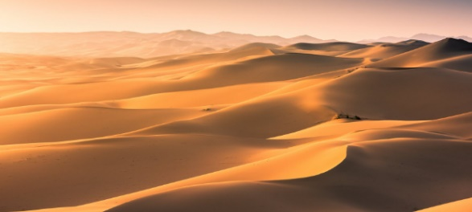  Sahara Desert, Egypt | 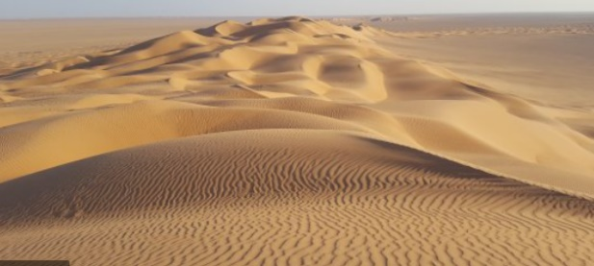  Rub' AI-Khali, Saudi Arabia
How does the physical geography of Southwest Asia and North Africa impact the population?
It has shaped the culture and the populations around the region. The regions are mostly dry people create houses with high roofs to prevent them from the hot sunlight, some of them migrate to cooler areas to search for water and shelter. Generally people are clustered but regions such as Nile River valley, Tigris river, Euphrates and Coastal Mediterranean sea are the areas with high populations.

Culture of Southwest Asia
Highlight the information in the text that has the greatest social effects. | Explain the immediate social effects of the highlighted characteristics.
- The Arabian Peninsula is largely united in religion, ethnicity, and culture. Its early civilizations had tribal structures based in family relationships. Some developed sheikdoms, and some were nomadic like the Bedouins who occupied most of the Arabian Peninsula.  - Today, the majority of the governments are absolute monarchies or constitutional monarchies.  - At one time, people lived in small rural villages or as clans of nomads. The peninsula's desert climate and the prospect of jobs have driven most people to settle in cities along the coasts.  - Once almost exclusively Arab, the population is changing due to immigrant workers attracted to jobs in the oil industry. Arabic, however, remains the common language, and the majority of immigrants are Muslims.  - Universal health care is offered in most countries, and education is mandatory for males, but less available for females. Men and women are generally segregated in public, and women often wear an abaya for modesty.  - In some countries, the wealth from oil has been used to improve infrastructure and education. Countries with less oil have promoted other economies such as banking and finance, but others still struggle against internal conflicts. | As these immigrants migrate are able to interact with the Arabs and even share ideas which may help them in future, strong relationships are create as they interact, and they end up creating communities and friends for lifetime. Others even get marriage partners which later becomes a family.  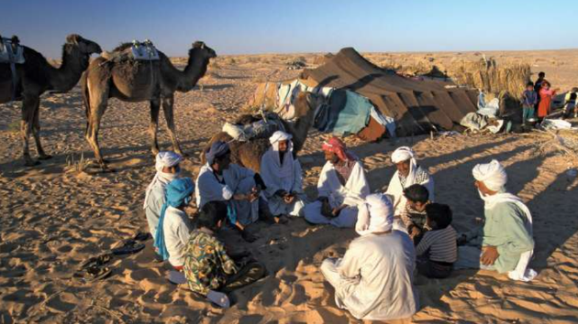
Summary question: How is the culture of Southwest Asia unique?
Their lives are dominated by Islamic observance. Since they are Muslims Friday is the holiest day for them. A lot of traditions and attitudes are centuries-old because they are derived from the Arab civilization. They don’t take alcoholic beverages hence we have no theatre and public exhibition of films.
Highlight the information in the text that has the greatest environmental effects. | Explain the immediate environmental effects of the highlighted characteristics.
- The average temperature of the subregion has been increasing, while rainfall has been decreasing. Droughts are affecting soil fertility, and some areas are facing desertification.  - Oil extraction and processing release chemical gases in the air, which then fall to the ground with rain, contaminating groundwater and soil. Burning fossil fuels releases carbon dioxide to the air, which is believed to contribute to the subregion's warming climate.  - The rapidly growing population is putting a strain on the subregion's limited water supply. There is little surface water from rainfall, and the amount of water being pulled from aquifers is increasing at an unsustainable rate.  - One solution to the lack of freshwater is desalination. The process, however, is expensive, requires a great deal of energy, and presents problems with disposal of the brine. New methods of farming are also being tested to reduce irrigation. | As these gases reach the ground, they bring health problems and diseases such as cancer and breathing problems. This gases also lead to acidic rain which destroys tress hence bringing down forests. Soil is also destroyed and no cultivation can take place hence leading to hunger. Finally, the gases also destroy the ozone layer therefore the sun rays hit the directly leading to drought.  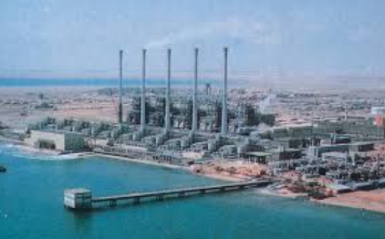  Desalination Plant
Summary question: How are the issues in the Middle East connected to the physical geography of the region?
The middle East consists of industries which emit dangerous gases to the environment, this gases destroy the ozone layer hence rays from the sun hit the ground leading to risen temperatures and even drought. The gases also lead to rise of different disease that make people weak hence they are not able to do heavy jobs like cultivating the land by planting trees.
Modern Issues in the Middle East
Geography, Culture, and Issues in the Transition Zone
Highlight the information in the text that has the greatest economic effects. | Explain the immediate economic effects of the highlighted characteristics.
- The deserts of North Africa neighbor the tropical savanna of Equatorial Africa. A border of vegetation produces a shore-like appearance, giving the area the name Sahel, meaning "shore” or "coast."  - The human-made Lake Volta was created to store water for generating hydroelectric power and is used for irrigation. Preventing the annual floods from the river and halting the course of flow, however, have reduced soil fertility and increased diseases.  - As trade in gold and salt increased between Africa and Europe, European powers began claiming African territories. Colonial boundaries were formed without considering cultures or religions, merging Muslim and animist societies while introducing Christianity.  - As countries achieved independence, ethnic groups struggled for power within old colonial boundaries, as they did in the conflict between Islamic-style and secular governments in Sudan.  - Many people have moved to cities as agricultural lands suffered from drought or overuse; however, nomadic herding and subsistence farming still support most of the population.  - Water shortages, due to climate change, lead to desertification, which is the destruction of land in arid and semiarid climates.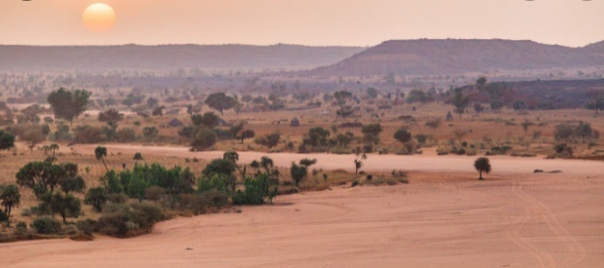  - The growing population means more crops, trees, and livestock are needed, putting further stress on the land. Better crop varieties and new ways to conserve water might help bring back the land. The Great Green Wall project is an attempt to stop the spread of the Sahara. | As the population grows more people will plant trees and start cultivating the land. This will rice the economy because people will employed to work on the farms and being paid for their labor. This food will be sold to different countries hence improving the economy also new business will be set on those areas

Geography, Culture, and Issues of East Africa
Highlight the information in the text that has the greatest social effects. | Explain the immediate social effects of the highlighted characteristics.
- Shifting tectonic plates caused great faults in the Earth, forming the Great Rift Valley that extends through East Africa.  - Soil erosion, deforestation, and desertification plague the Sahel, while the savanna receives seasonal rainfall that supports wildlife and a variety of vegetation. The Serengeti Plain, one of the world's largest savanna plains, is home to zebras, gazelles, hyenas, lions, giraffes, and more.  - Traders from the Arabian Peninsula brought their language and the Islamic religion. Persians and Chinese settled areas, and the Portuguese took control of the Indian Ocean, bringing with them Roman Catholicism.  - Further European colonization established borders without regard to traditional tribal territories, and cash crops for exports replaced the crops needed locally. As colonies gained independence, conflicts over leadership, discrimination, and economic health arose.  - East Africa's landscape and climate influenced how the many different indigenous and immigrant populations settled. The highest population densities are on fertile lands and near ocean coasts or rivers.  - English and French serve as a common language; however, many other languages are spoken, from Arabic to Persian to indigenous. Most people are Muslim or Christian, though animist beliefs are still practiced.  - Literacy rates have improved, though few students enroll in secondary school, and women generally maintain traditional roles, working farms but unable to own the land. Agriculture makes up 90 percent of employment, with ecotourism a growing industry.  - Wars are a major cause of hunger, putting a strain on limited food resources and diverting attention from the important tasks of managing both resources and economic growth.  - Poaching is another environmental threat. In the past fifty years, the elephant population has dropped from 2 million to 600,000, and rhinoceroses face extinction due to the demand for their horns.  - Countries are coming together to better manage the environment through reforestation and the creation of national parks and wildlife reserves. The resulting tourism boosts the economy and increases support for conservation. | 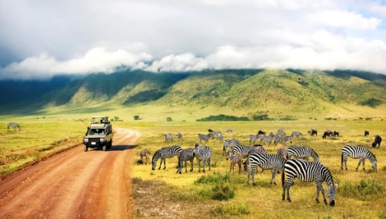  These traders as they associate with buyers, they are able to exchange different ideas. This enables them to associate with one another leading to strong relationships. This new ideas are afterward shared to communities with shares them from one generation to another. They are also able to learn different languages as they trade.

Geography, Culture, and Issues of South Africa
Highlight the information in the text that has the greatest environmental effects. | Explain the immediate environmental effects of the highlighted characteristics.
- Southern Africa's mainland is surrounded by ocean on three sides. The u-shaped Great Escarpment rises up from the coastlands and is comprised of steep cliffs.  - Inside the Great Escarpment, savannas cover the north and east, and are home to giraffes, zebras, lions, leopards, elephants, and more. The south and west are mostly desert, with some regions able to support grasses and animals such as antelope and ostriches.  - Going from west to east, Southern Africa's population increases due to the area's physical geography. Trade routes brought people to the coasts, and deserts prohibited settlement. The discovery of gold also gave rise to settlements and eventually cities.  - The European influence is felt today in Southern Africa. French, German, and English are spoken in many places, and Christianity is the most common religion.  - Poverty and disease continue to be problems, and gender inequality persists due to the focus on traditional family roles. Most people are farmers, but mining for gold, diamonds, copper, and cobalt are also important to the economy.  - Having no gas or electric, many people rely on firewood, which puts a strain on forest resources. Logging and clearing land for agriculture put an even greater strain on the forests, and poaching is threatening species like the elephant and rhinoceros.  - Even when water is plentiful, it is often contaminated. As populations increase, groundwater is being tapped without management, and irrigation practices often supply the wealthy, while draining supplies from the poor.  - As more and more people migrate to cities in search of jobs, urban areas already lacking in sanitation become more polluted and resources are further strained.  - To combat the environmental problems, many countries are adopting laws to protect wildlife and natural resources and reduce air and water pollution. Corrupt governments, however, sometimes prevent help from reaching where it is needed. | 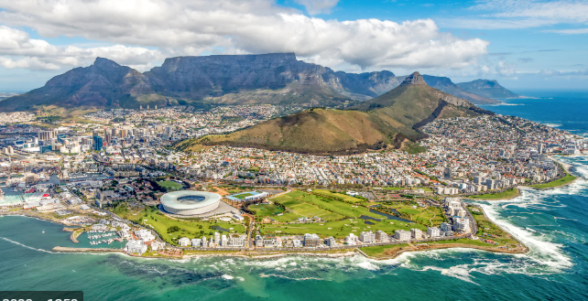  This will have a great impact on the environment because as we all know forest is a home of different animals but because people want firewood, they will clear the forest forcing the animals to evacuate which are later they find themselves on human territory and end up to be killed. Once the forest is cleared the area will receive low rainfall which will reduce as time goes buy and later the area will be drying and no cultivation will take place.

Summary Question: How are the regions of Africa similar?
Most of regions consist of features such as mountains, rivers, forest and most of the regions are landlocked which bring same effects and conditions to those regions. Most of the regions are covered by forests and rivers.
How are the regions of Africa different?
We have the northern part which is occupied by desert, regions around the desert receives different temperatures compare to the regions away from deserted areas.

